44.23: Conservation of strangeness:

a) 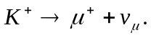 Strangeness is not conserved since there is just one strange
particle, in the initial states.

b) 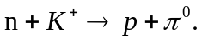 Again there is just one strange particle so strangeness
cannot be conserved.
c) so strangeness is conserved.
d) so strangeness is conserved.

